FACULTY EVALUATION
Programme Name: Social Entrepreneurship Program (SEP)- Growth MASTERCLASS Module 1 Kenya (2nd March 2026 - 6th March 2026)
Session: Reflection and leadership and teams (employees)
Faculty Name: Naomi May Watetu Mwangi
No. of Respondents: 6
No. of Participants: 10
Evaluation Parameter | (%) Individual Score | (%) Programme Average
Punctuality (Commencement and Completion of Sessions) | 93 | 93
How well do you understand the core concepts presented? | 97 | 95
Rate your confidence in applying the new skills learnt | 93 | 88
Degree of Faculty preparedness for the sessions | 93 | 95
Content and methodology of the program | 97 | 96
Quality of class and group discussions | 90 | 89
The information presented in the course is relevant to my work (ministry) | 100 | 97
Average scores | 95 | 93

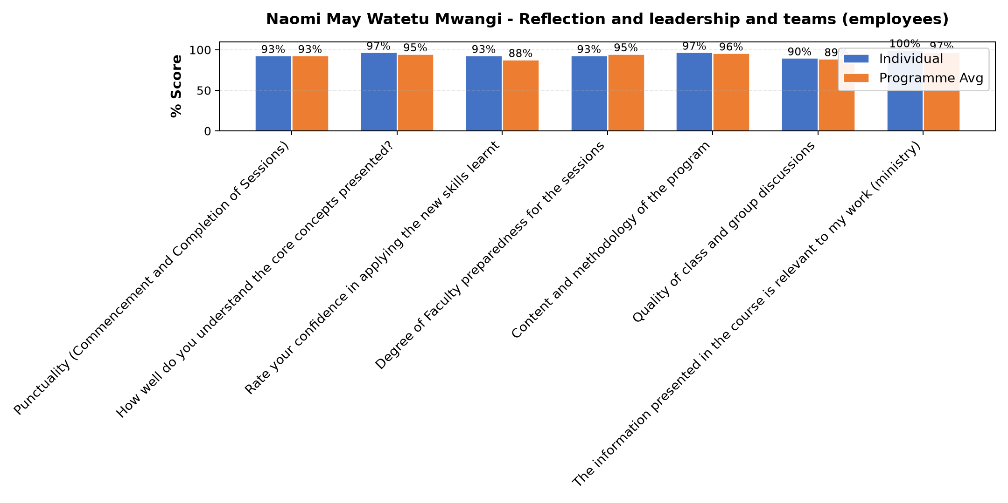

Comments & Feedback
- • Mitigation of personality and balancing differences of our ideologies in effective communication
- • Failure to understand my colour and my team members on the same. If there is no moderation.
- • No barrier will prevent me from applying what I have learnt today because I have discovered that it is necessary to know deeply even about the red personality who seems to too direct not following structures but learn to accommodate her in her weaknesses because no single colour is perfect,I have also learnt that delegation of authority does not mean that I should be asked or consulted every hour but give freedom
- • If I don't understand my color energy and that of my team members. In all I need moderation and personality awaness.
SUBMITTED THROUGH:
SBS Evaluation Automation System

